Hands on DAY31 – Keerthivasan R

📝 Problem Statement: Student Management System (CRUD)

📌 Background
A small coaching institute wants to maintain student records digitally instead of using manual registers. The system should allow administrators to manage student information efficiently.

🎯 Objective
Develop a simple database-driven application that performs CRUD operations (Create, Read, Update, Delete) on student records.

📂 Functional Requirements
The system should allow the user to:
- Create
  - Add a new student record.
  - Store details such as:
    - Student ID (Primary Key)
    - Name
    - Email
    - Phone Number
    - Course
    - Date of Admission
- Read
  - View all student records in a list format.
  - Search student by ID or Name.
  - View detailed information of a single student.
- Update
  - Edit existing student details.
  - Save updated information in the database.
- Delete
  - Remove a student record from the system.
  - Ask for confirmation before deletion.

🗄 Database Requirements

Table: Students
Column Name | Data Type | Constraints
StudentId | int | Primary Key, Identity
Name | varchar(100) | Not Null
Email | varchar(100) | Unique
Phone | varchar(15) | Not Null
Course | varchar(50) | Not Null
AdmissionDate | datetime | Not Null

⚙ Technical Constraints
- Use SQL Server as the database.
- Use Entity Framework (Database First or Code First).
- Implement MVC architecture.
- Apply basic validation (Required fields, Email format).
- Use proper routing for CRUD actions.

✅ Expected Outcome
- User-friendly interface.
- Properly connected database.
- All four CRUD operations working successfully.
- Data validation and error handling implemented.

CODE:
Model/ Student.cs
using System.ComponentModel.DataAnnotations;
using System.ComponentModel.DataAnnotations.Schema;

namespace StudentManagementSystem.Models
{
public class Student
{
[Key]
[DatabaseGenerated(DatabaseGeneratedOption.Identity)]
public int StudentId { get; set; }

[Required(ErrorMessage = "Name is required")]
[StringLength(100, MinimumLength = 2, ErrorMessage = "Name must be between 2 and 100 characters")]
[Display(Name = "Full Name")]
public string Name { get; set; } = string.Empty;

[Required(ErrorMessage = "Email is required")]
[EmailAddress(ErrorMessage = "Invalid email format")]
[StringLength(100)]
[Display(Name = "Email Address")]
public string Email { get; set; } = string.Empty;

[Required(ErrorMessage = "Phone number is required")]
[StringLength(15, MinimumLength = 10, ErrorMessage = "Phone number must be 10-15 digits")]
[Phone(ErrorMessage = "Invalid phone number")]
[Display(Name = "Phone Number")]
public string Phone { get; set; } = string.Empty;

[Required(ErrorMessage = "Course is required")]
[StringLength(50)]
[Display(Name = "Course Name")]
public string Course { get; set; } = string.Empty;

[Required(ErrorMessage = "Admission date is required")]
[DataType(DataType.Date)]
[Display(Name = "Admission Date")]
[DisplayFormat(DataFormatString = "{0:yyyy-MM-dd}", ApplyFormatInEditMode = true)]
public DateTime AdmissionDate { get; set; } = DateTime.Now;
}
}
Data / ApplicationDbContext.cs
using Microsoft.EntityFrameworkCore;
using StudentManagementSystem.Models;

namespace StudentManagementSystem.Data
{
public class ApplicationDbContext : DbContext
{
public ApplicationDbContext(DbContextOptions<ApplicationDbContext> options)
: base(options)
{
}

public DbSet<Student> Students { get; set; }

protected override void OnModelCreating(ModelBuilder modelBuilder)
{
base.OnModelCreating(modelBuilder);

// Configure Email as Unique
modelBuilder.Entity<Student>()
.HasIndex(s => s.Email)
.IsUnique();

// Seed some initial data
modelBuilder.Entity<Student>().HasData(
new Student
{
StudentId = 1,
Name = "John Doe",
Email = "john@example.com",
Phone = "9876543210",
Course = "Computer Science",
AdmissionDate = new DateTime(2024, 1, 15)
},
new Student
{
StudentId = 2,
Name = "Jane Smith",
Email = "jane@example.com",
Phone = "9876543211",
Course = "Mathematics",
AdmissionDate = new DateTime(2024, 1, 20)
}
);
}
}
}
Controllers/ StudentController.cs
using Microsoft.AspNetCore.Mvc;
using Microsoft.EntityFrameworkCore;
using StudentManagementSystem.Data;
using StudentManagementSystem.Models;

namespace StudentManagementSystem.Controllers
{
public class StudentController : Controller
{
private readonly ApplicationDbContext _context;

public StudentController(ApplicationDbContext context)
{
_context = context;
}

// GET: Student/Index - List all students
public async Task<IActionResult> Index(string searchString)
{
var students = from s in _context.Students
select s;

if (!string.IsNullOrEmpty(searchString))
{
students = students.Where(s => s.Name.Contains(searchString) ||
s.StudentId.ToString().Contains(searchString));
}

ViewData["CurrentFilter"] = searchString;
return View(await students.ToListAsync());
}

// GET: Student/Details/5 - View student details
public async Task<IActionResult> Details(int? id)
{
if (id == null)
{
return NotFound();
}

var student = await _context.Students
.FirstOrDefaultAsync(m => m.StudentId == id);

if (student == null)
{
return NotFound();
}

return View(student);
}

// GET: Student/Create - Show create form
public IActionResult Create()
{
return View();
}

// POST: Student/Create - Add new student
[HttpPost]
[ValidateAntiForgeryToken]
public async Task<IActionResult> Create([Bind("Name,Email,Phone,Course,AdmissionDate")] Student student)
{
if (ModelState.IsValid)
{
// Check if email already exists
var existingStudent = await _context.Students
.FirstOrDefaultAsync(s => s.Email == student.Email);

if (existingStudent != null)
{
ModelState.AddModelError("Email", "This email is already registered");
return View(student);
}

_context.Add(student);
await _context.SaveChangesAsync();
TempData["SuccessMessage"] = "Student added successfully!";
return RedirectToAction(nameof(Index));
}
return View(student);
}

// GET: Student/Edit/5 - Show edit form
public async Task<IActionResult> Edit(int? id)
{
if (id == null)
{
return NotFound();
}

var student = await _context.Students.FindAsync(id);
if (student == null)
{
return NotFound();
}
return View(student);
}

// POST: Student/Edit/5 - Update student
[HttpPost]
[ValidateAntiForgeryToken]
public async Task<IActionResult> Edit(int id, [Bind("StudentId,Name,Email,Phone,Course,AdmissionDate")] Student student)
{
if (id != student.StudentId)
{
return NotFound();
}

if (ModelState.IsValid)
{
try
{
// Check if email exists for another student
var existingStudent = await _context.Students
.FirstOrDefaultAsync(s => s.Email == student.Email && s.StudentId != student.StudentId);

if (existingStudent != null)
{
ModelState.AddModelError("Email", "This email is already registered to another student");
return View(student);
}

_context.Update(student);
await _context.SaveChangesAsync();
TempData["SuccessMessage"] = "Student updated successfully!";
}
catch (DbUpdateConcurrencyException)
{
if (!StudentExists(student.StudentId))
{
return NotFound();
}
else
{
throw;
}
}
return RedirectToAction(nameof(Index));
}
return View(student);
}

// GET: Student/Delete/5 - Show delete confirmation
public async Task<IActionResult> Delete(int? id)
{
if (id == null)
{
return NotFound();
}

var student = await _context.Students
.FirstOrDefaultAsync(m => m.StudentId == id);
if (student == null)
{
return NotFound();
}

return View(student);
}

// POST: Student/Delete/5 - Delete student
[HttpPost, ActionName("Delete")]
[ValidateAntiForgeryToken]
public async Task<IActionResult> DeleteConfirmed(int id)
{
var student = await _context.Students.FindAsync(id);
if (student != null)
{
_context.Students.Remove(student);
await _context.SaveChangesAsync();
TempData["SuccessMessage"] = "Student deleted successfully!";
}

return RedirectToAction(nameof(Index));
}

private bool StudentExists(int id)
{
return _context.Students.Any(e => e.StudentId == id);
}
}
}
Views / Students / Index.cshtml
@model IEnumerable<StudentManagementSystem.Models.Student>

@{
ViewData["Title"] = "Student List";
}

<h2>Student Management System</h2>

@if (TempData["SuccessMessage"] != null)
{
<div class="alert alert-success alert-dismissible fade show" role="alert">
@TempData["SuccessMessage"]
<button type="button" class="btn-close" data-bs-dismiss="alert"></button>
</div>
}

<p>
<a asp-action="Create" class="btn btn-primary">Add New Student</a>
</p>

<form asp-action="Index" method="get" class="mb-3">
<div class="row">
<div class="col-md-6">
<div class="input-group">
<input type="text" name="searchString" value="@ViewData["CurrentFilter"]"
class="form-control" placeholder="Search by Name or ID" />
<button type="submit" class="btn btn-secondary">Search</button>
<a asp-action="Index" class="btn btn-outline-secondary">Clear</a>
</div>
</div>
</div>
</form>

<table class="table table-striped table-hover">
<thead class="table-dark">
<tr>
<th>@Html.DisplayNameFor(model => model.StudentId)</th>
<th>@Html.DisplayNameFor(model => model.Name)</th>
<th>@Html.DisplayNameFor(model => model.Email)</th>
<th>@Html.DisplayNameFor(model => model.Phone)</th>
<th>@Html.DisplayNameFor(model => model.Course)</th>
<th>@Html.DisplayNameFor(model => model.AdmissionDate)</th>
<th>Actions</th>
</tr>
</thead>
<tbody>
@foreach (var item in Model)
{
<tr>
<td>@Html.DisplayFor(modelItem => item.StudentId)</td>
<td>@Html.DisplayFor(modelItem => item.Name)</td>
<td>@Html.DisplayFor(modelItem => item.Email)</td>
<td>@Html.DisplayFor(modelItem => item.Phone)</td>
<td>@Html.DisplayFor(modelItem => item.Course)</td>
<td>@item.AdmissionDate.ToString("dd-MMM-yyyy")</td>
<td>
<a asp-action="Details" asp-route-id="@item.StudentId" class="btn btn-info btn-sm">Details</a>
<a asp-action="Edit" asp-route-id="@item.StudentId" class="btn btn-warning btn-sm">Edit</a>
<a asp-action="Delete" asp-route-id="@item.StudentId" class="btn btn-danger btn-sm">Delete</a>
</td>
</tr>
}
</tbody>
</table>

@if (!Model.Any())
{
<div class="alert alert-info">
No students found. Click "Add New Student" to add your first student.
</div>
}
Views/ Students/ Create.cshtml
@model StudentManagementSystem.Models.Student

@{
ViewData["Title"] = "Add New Student";
}

<h2>Add New Student</h2>

<form asp-action="Create" method="post">
<div asp-validation-summary="ModelOnly" class="text-danger"></div>

<div class="row mb-3">
<div class="col-md-6">
<label asp-for="Name" class="form-label"></label>
<input asp-for="Name" class="form-control" />
<span asp-validation-for="Name" class="text-danger"></span>
</div>
<div class="col-md-6">
<label asp-for="Email" class="form-label"></label>
<input asp-for="Email" class="form-control" type="email" />
<span asp-validation-for="Email" class="text-danger"></span>
</div>
</div>

<div class="row mb-3">
<div class="col-md-6">
<label asp-for="Phone" class="form-label"></label>
<input asp-for="Phone" class="form-control" />
<span asp-validation-for="Phone" class="text-danger"></span>
</div>
<div class="col-md-6">
<label asp-for="Course" class="form-label"></label>
<input asp-for="Course" class="form-control" />
<span asp-validation-for="Course" class="text-danger"></span>
</div>
</div>

<div class="row mb-3">
<div class="col-md-6">
<label asp-for="AdmissionDate" class="form-label"></label>
<input asp-for="AdmissionDate" class="form-control" type="date" />
<span asp-validation-for="AdmissionDate" class="text-danger"></span>
</div>
</div>
<div class="row">
<div class="col-md-12">
<button type="submit" class="btn btn-primary">Save Student</button>
<a asp-action="Index" class="btn btn-secondary">Cancel</a>
</div>
</div>
</form>

@section Scripts {
@{
await Html.RenderPartialAsync("_ValidationScriptsPartial");
}
}
Views / Students / Edits.cshtml
@model StudentManagementSystem.Models.Student

@{
ViewData["Title"] = "Edit Student";
}

<h2>Edit Student</h2>

<form asp-action="Edit" method="post">
<div asp-validation-summary="ModelOnly" class="text-danger"></div>
<input type="hidden" asp-for="StudentId" />

<div class="row mb-3">
<div class="col-md-6">
<label asp-for="Name" class="form-label"></label>
<input asp-for="Name" class="form-control" />
<span asp-validation-for="Name" class="text-danger"></span>
</div>
<div class="col-md-6">
<label asp-for="Email" class="form-label"></label>
<input asp-for="Email" class="form-control" type="email" />
<span asp-validation-for="Email" class="text-danger"></span>
</div>
</div>

<div class="row mb-3">
<div class="col-md-6">
<label asp-for="Phone" class="form-label"></label>
<input asp-for="Phone" class="form-control" />
<span asp-validation-for="Phone" class="text-danger"></span>
</div>
<div class="col-md-6">
<label asp-for="Course" class="form-label"></label>
<input asp-for="Course" class="form-control" />
<span asp-validation-for="Course" class="text-danger"></span>
</div>
</div>

<div class="row mb-3">
<div class="col-md-6">
<label asp-for="AdmissionDate" class="form-label"></label>
<input asp-for="AdmissionDate" class="form-control" type="date" />
<span asp-validation-for="AdmissionDate" class="text-danger"></span>
</div>
</div>

<div class="row">
<div class="col-md-12">
<button type="submit" class="btn btn-primary">Update Student</button>
<a asp-action="Index" class="btn btn-secondary">Cancel</a>
</div>
</div>
</form>
@section Scripts {
@{
await Html.RenderPartialAsync("_ValidationScriptsPartial");
}
}
Views /Students/ Details.cshtml
@model StudentManagementSystem.Models.Student

@{
ViewData["Title"] = "Student Details";
}

<h2>Student Details</h2>

<div class="card">
<div class="card-body">
<dl class="row">
<dt class="col-sm-3">Student ID</dt>
<dd class="col-sm-9">@Model.StudentId</dd>

<dt class="col-sm-3">Name</dt>
<dd class="col-sm-9">@Model.Name</dd>

<dt class="col-sm-3">Email</dt>
<dd class="col-sm-9">@Model.Email</dd>

<dt class="col-sm-3">Phone</dt>
<dd class="col-sm-9">@Model.Phone</dd>

<dt class="col-sm-3">Course</dt>
<dd class="col-sm-9">@Model.Course</dd>

<dt class="col-sm-3">Admission Date</dt>
<dd class="col-sm-9">@Model.AdmissionDate.ToString("dd MMMM yyyy")</dd>
</dl>
</div>
</div>

<p class="mt-3">
<a asp-action="Edit" asp-route-id="@Model.StudentId" class="btn btn-warning">Edit</a>
<a asp-action="Index" class="btn btn-secondary">Back to List</a>
</p>
Views / Student / Delete.cshtml
@model StudentManagementSystem.Models.Student

@{
ViewData["Title"] = "Delete Student";
}

<h2>Delete Student</h2>

<div class="alert alert-danger">
<h4>Are you sure you want to delete this student?</h4>
<p>This action cannot be undone.</p>
</div>

<div class="card">
<div class="card-body">
<dl class="row">
<dt class="col-sm-3">Student ID</dt>
<dd class="col-sm-9">@Model.StudentId</dd>

<dt class="col-sm-3">Name</dt>
<dd class="col-sm-9">@Model.Name</dd>

<dt class="col-sm-3">Email</dt>
<dd class="col-sm-9">@Model.Email</dd>

<dt class="col-sm-3">Phone</dt>
<dd class="col-sm-9">@Model.Phone</dd>

<dt class="col-sm-3">Course</dt>
<dd class="col-sm-9">@Model.Course</dd>

<dt class="col-sm-3">Admission Date</dt>
<dd class="col-sm-9">@Model.AdmissionDate.ToString("dd MMMM yyyy")</dd>
</dl>
</div>
</div>

<form asp-action="Delete" method="post" class="mt-3">
<input type="hidden" asp-for="StudentId" />
<button type="submit" class="btn btn-danger">Yes, Delete</button>
<a asp-action="Index" class="btn btn-secondary">Cancel</a>
</form>
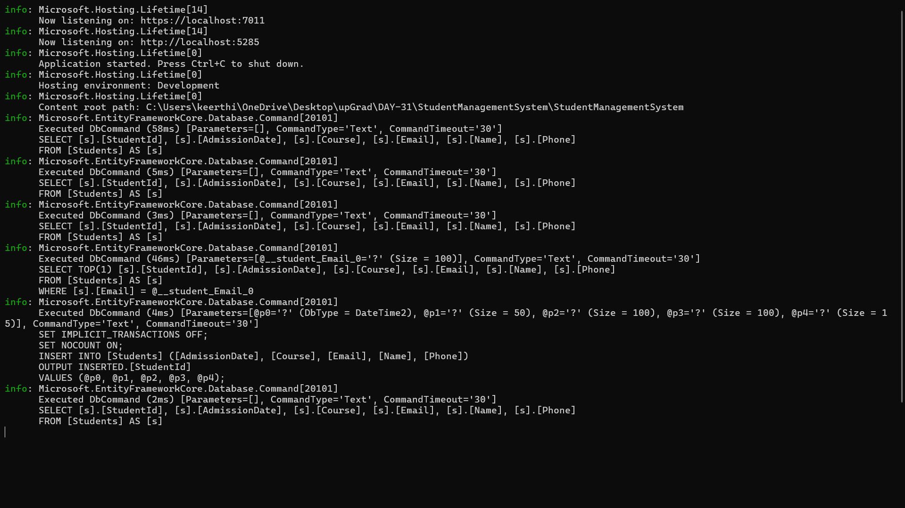
OUTPUT:

